ASSY, PST MODULATION

 | Description | Part number | Qty Per Assy |  | Photo
1 | BRACKET, MTG, PST MODULATION | 4281 | 2 |  | 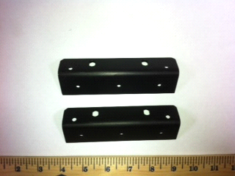
2 | PLATE, JOINING, PST MODULATION | 4282 | 1 |  | 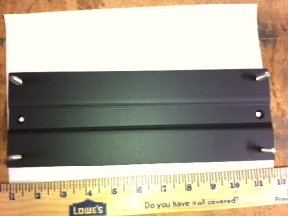
3 | CHASSIS, PST MODULATION | 4283 | 1 |  | 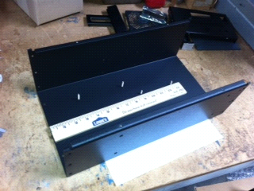
4 | PANEL, FRONT, PST MODULATION | 4286 | 1 |  | 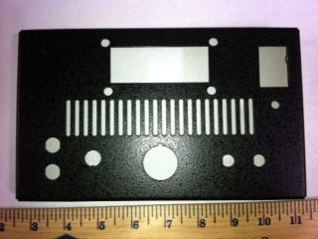
5 | PANEL, REAR, PST MODULATION | 4287 | 1 |  | 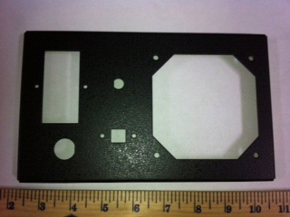
6 | COVER, PST MODULATION | 4288 | 1 |  | 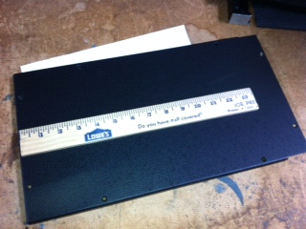
7 | CLAMP, TOE, HEAT SINK, PST | 4306 | 2 |  | 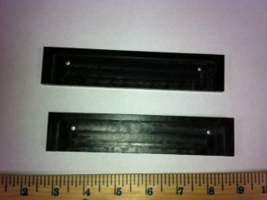
8 | PLATE, ELECTRICAL ISOLATION, PST | 4307 | 1 |  | 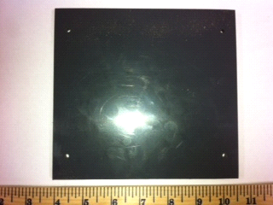
9 | DISPLAY, LCD, CHARACTER DISPLAY MODULE | P1454 | 1 |  | 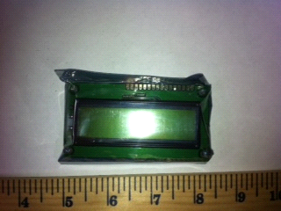
10 | BEZEL, LCD DISPLAY WITH MOUNTING KIT | P1455 | 1 |  | 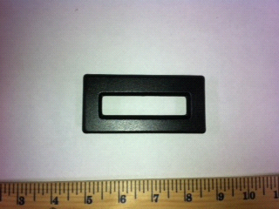
11 | SWITCH, POWER, AC | P1456 | 1 |  | 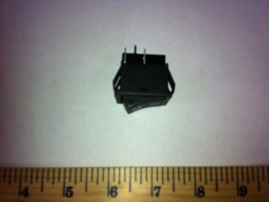
12 | JACK, BANANA, RED | P1457 | 1 |  | 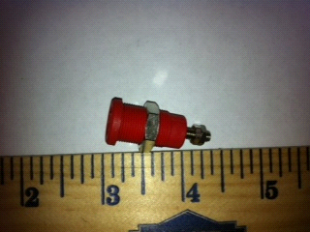
13 | JACK, BANANA, BLACK | P1458 | 1 |  | 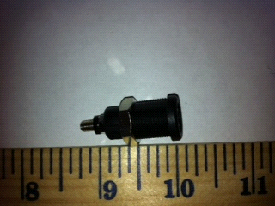
14 | SWITCH, TOGGLE | P1459 | 1 |  | 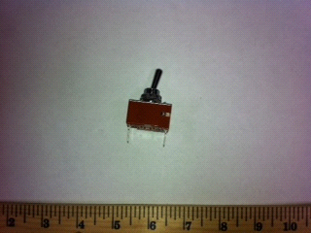
15 | POTENTIOMETER, 100K OHM, 10 TURN | P1460 | 1 |  | 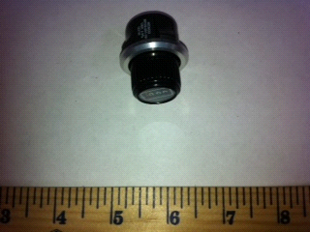
16 | CONNECTOR, BNC, STRAIGHT | P1461 | 3 | 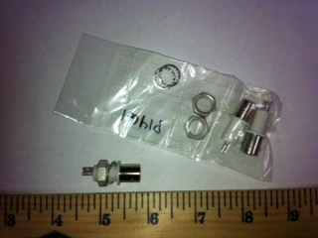
17 | LED, PANEL, GREEN | P1462 | 1 | 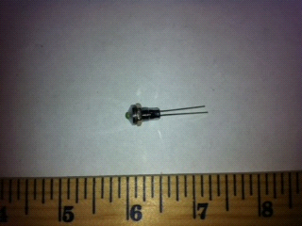
18 | SWITCH, POWER MODULE, 5A | P1463 | 1 | 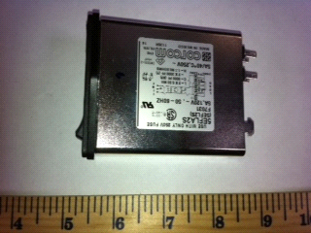
19 | FAN, 12VDC, BRUSHLESS, 3.6" X 3.6" | P1464 | 1 | 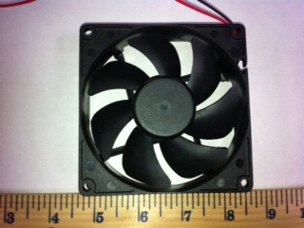
20 | CONNECTOR, RCPT, 3 PIN | P1465 | 1 | 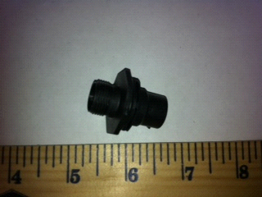
21 | HEAT SINK, 0.7 C/W PM | P1467 | 1 | 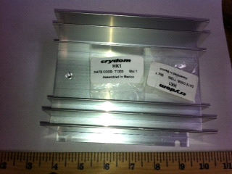
22 | POWER SUPPLY, 80W, 12V, 6.66 A | P1468 | 1 | 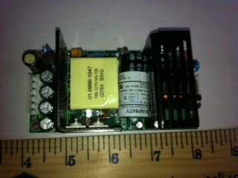
23 | CONVERTER, DC-DC 28V, 3.57A, 100W | P1469 | 1 | 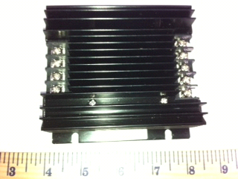
24 | CONVERTER, DC/DC, 10W, 5V, 1A | P1470 | 1 | 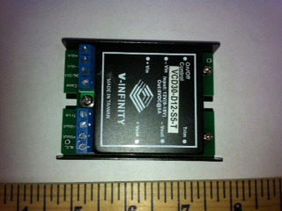
25 | HANDLE, PULL | P1471 | 2 | 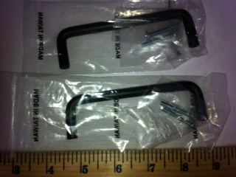
26 | COVER, FAN, 82.5MM HOLE SP | P1472 | 1 | 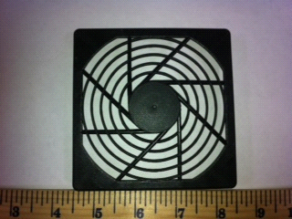
27 | SPACER, FOR #2 SCREW, 1/4" LG. | P1473 | 4 | 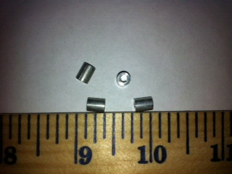
28 | ROD, THREADED, #2-56 X 1" LG. | P1474 | 4 | 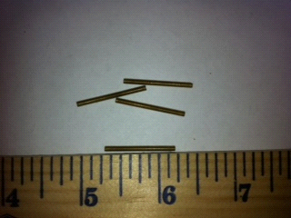
29 | CABLE, USB, 2.0 B FEMALE TO B MALE | P1475 | 1 | 